Drag and drop finder tool on Edit three things

Title: Open

class: Edit

instance:1

--------------------------------------------------------------------

Drag and drop finder tool on submit button(open button) three things

Title: Open

class: button

instance:1

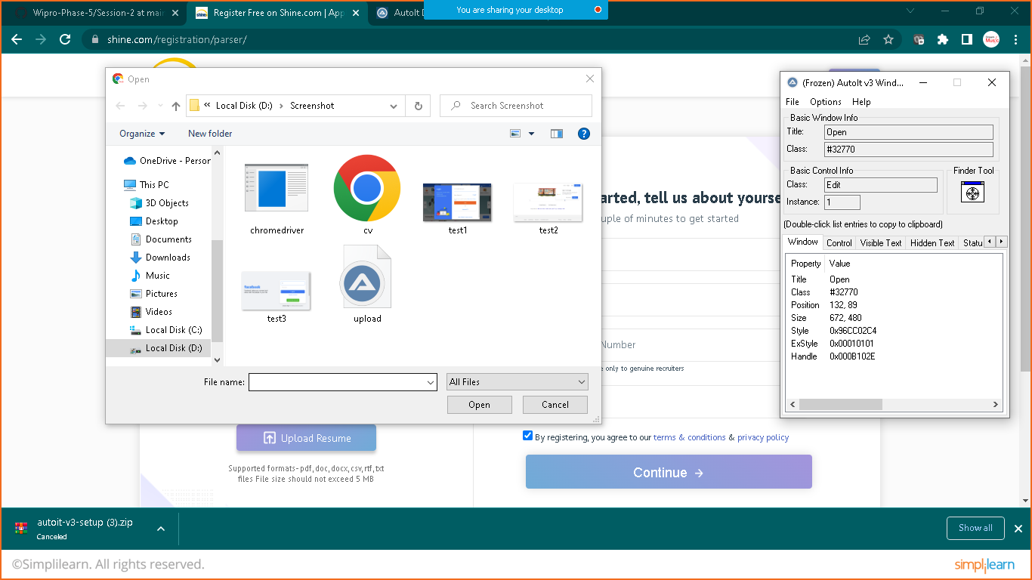

now we will use this details to write automation script for windows

----------------------------------------------------------------------

goto : C:\Program Files (x86)\AutoIt3\SciTE

Click on SciTE

and write down below script

------------------------------------------------------

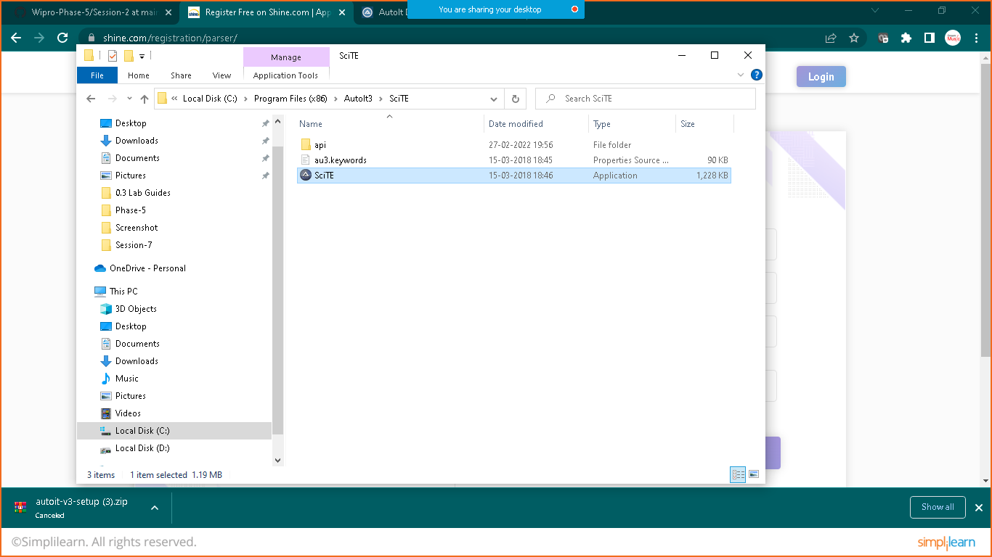

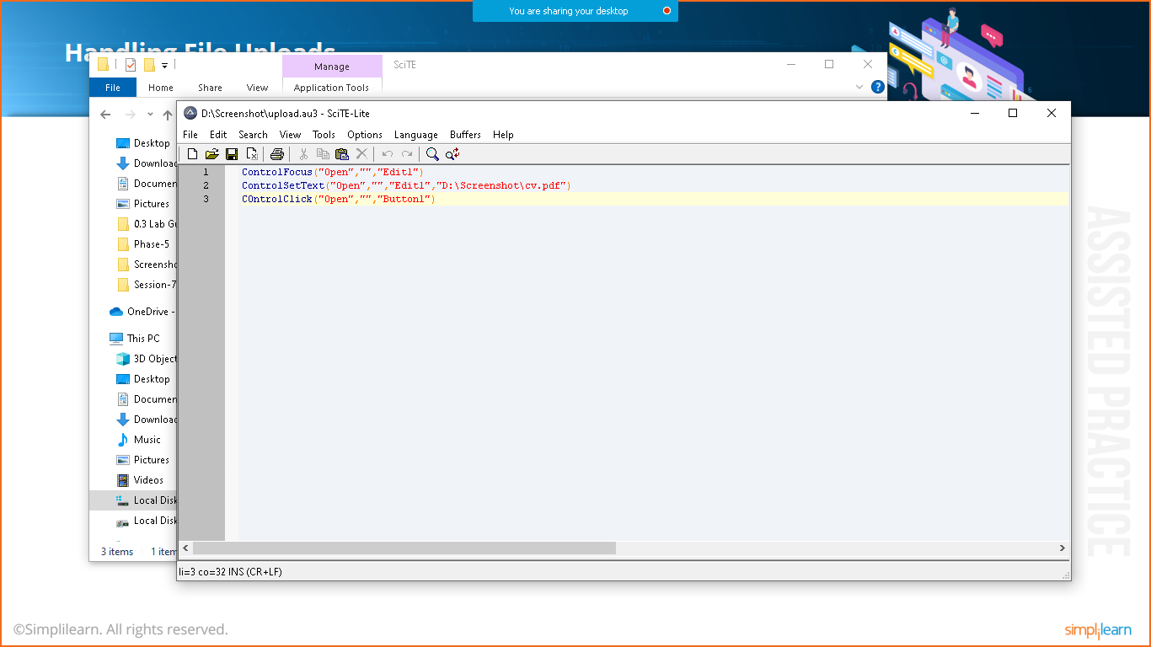

ControlFocus("Open","","Edit1")

ControlSetText("Open","","Edit1","path_of_your_file")

COntrolClick("Open","","Button")

-----------------------------------------------------

save the file : upload.au3 extension in the same location where your document is saved

now go to the folder where your document was saved there you will find out one uplod.au3 file

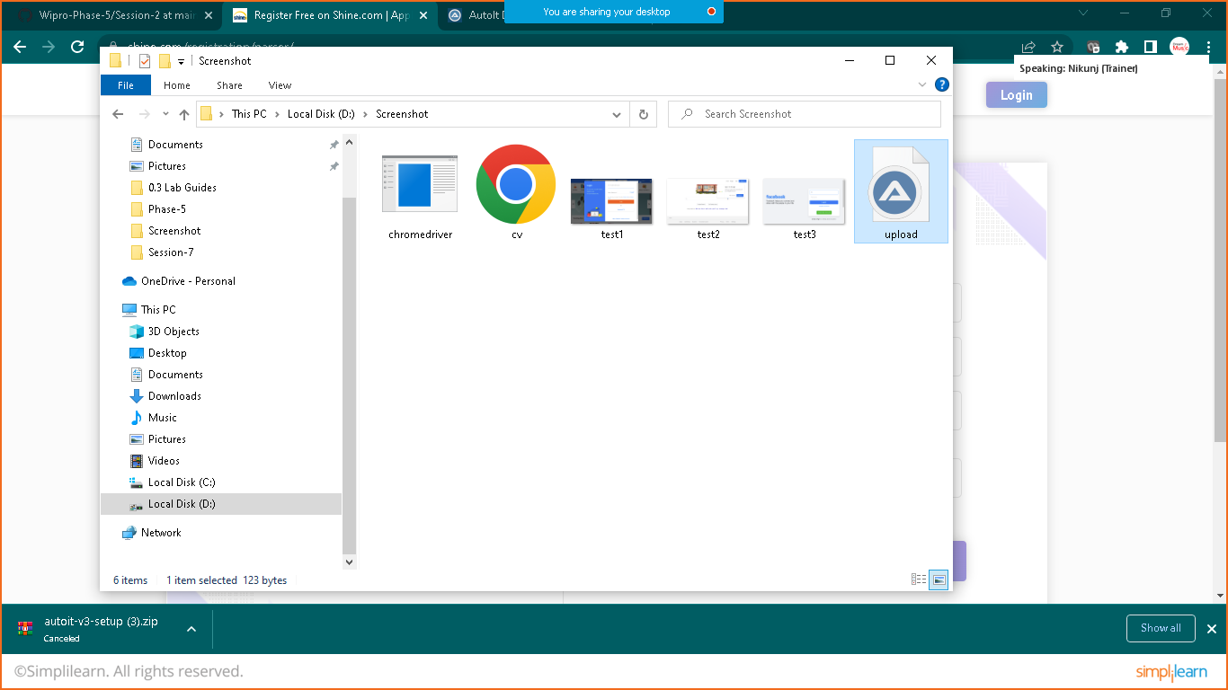

Right click on it and choose compile script

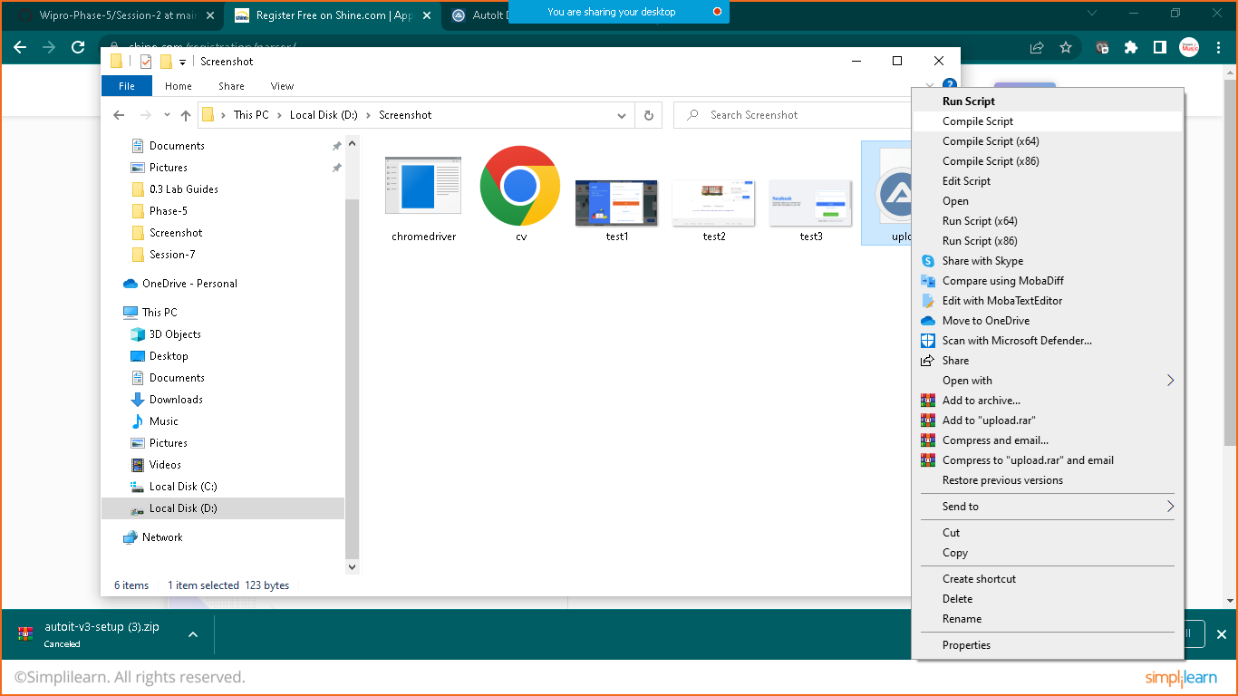

Now it will prepare new **Upload.exe** file

Now prepare one java program in eclips as below and run as java application

**package** com.simplilearn.driver;

**import** java.io.IOException;

**import** org.openqa.selenium.By;

**import** org.openqa.selenium.JavascriptExecutor;

**import** org.openqa.selenium.WebDriver;

**import** org.openqa.selenium.WebElement;

**import** org.openqa.selenium.chrome.ChromeDriver;

**public** **class** AutoIt {

**public** **static** **void** main(String[] args) **throws** IOException,InterruptedException {

//assigning driver path

String path="D:\\Phase-5\\chromedriver_win32_new\\chromedriver.exe";

System.*setProperty*("webdriver.chrome.driver", path);

//initiate the driver

WebDriver driver= **new** ChromeDriver();

//giving Base Url

String base_url="https://www.shine.com/register/general/";

//launching in chrome

driver.get(base_url);

//getting name

WebElement name= driver.findElement(By.*id*("id_name"));

name.sendKeys("Nikunj Soni");

WebElement element= driver.findElement(By.*id*("id_file"));

JavascriptExecutor executor=(JavascriptExecutor) driver;

executor.executeScript("arguments[0].click();", element);

Thread.*sleep*(5000);

Runtime.*getRuntime*().exec("D:\\Screenshot\\upload.exe");

}

}

Note: D:\\Screenshot\\upload.exe

This the the path of complied script prepared using autoit